 JULY 2019 

 July 1 - Borough Council Meeting at 7:00 pm

July 1 – Kids Carnival - Danville Assembly God Church 4 – 8 pm

734 Sixth Street, Riverside

July 4 - Independence Day - 

Borough Offices **Closed** for Independence Day Holiday

July 19-21 **Danville Heritage Events**

See website for the list of events: [WWW.DanvilleHeritage.Com](http://WWW.DanvilleHeritage.Com)

July 20 – Parade Celebrating American Legion Post 40 100th Anniversary 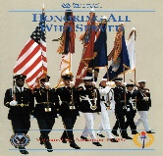

& Danville Heritage - Parade forms at 3 pm, Paper Magic, Moves at 5 pm

Block Party at Cole’s Hardware Parking Lot following Parade

20th - dark - Fireworks over the River!

21st - Hymn Sing along the river @ 6:30 pm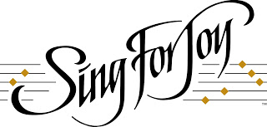

Concerts in the Park - Tuesdays at 7:00 pm - Memorial Park, Danville

7/2 – KJ & Funshine Band – KJ Reimensnyder-Wagner,Tim Latshaw,Sean Madden

7/9 - The Clickard Consortium - Cool Jazz Orchestra

7/16 –Prairie Dogma – Americana rock,Country,Deep Tracks

7/23 – Van Wagner – Songwriter, singer, storyteller

7/30 – West Branch Barbershop Chorus – classic harmonies

**Tax collector, Rebecca Steckley, will have office hours in the Municipal Building on Tuesdays & Thursdays, 4:30 pm - 6:00 pm, beginning July 10th.**