2021 CELEBRATION FUNDRAISER ITEMS! 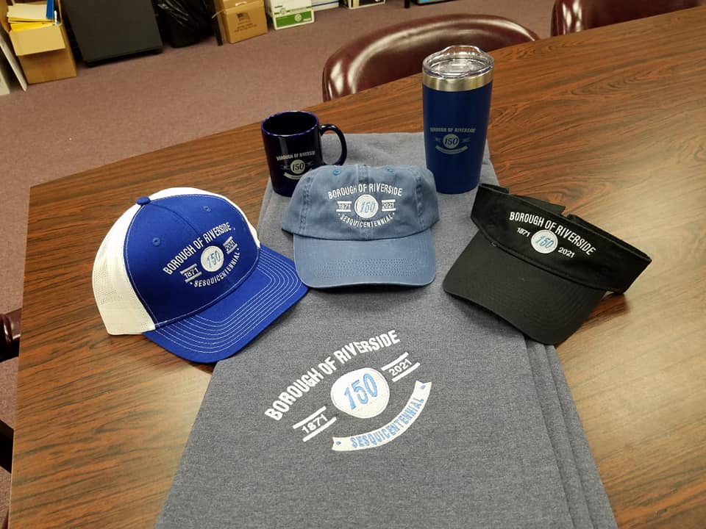
Stadium Blanket - $20.00
Baseball Cap – either style - $15.00
Visor - $10.00
Tumbler Travel Mug - $15.00
Coffee Mug - $5.00
Purchase at Borough Office, 415 Dewart Street, Riverside or call Debbie 570 380-4310

